PRESS RELEASE
United Nations Resident Coordinator in Sierra Leone’s Statement on the International Women Day
8 March 2021
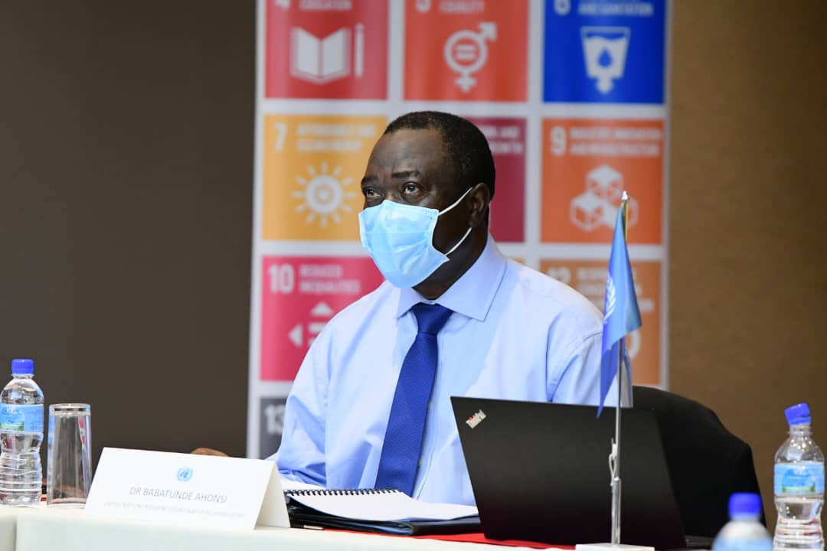

Freetown, Sierra Leone: Ever since 1977, when the United Nations General Assembly invited member states to proclaim 8 March as International Women’s Day (IWD), Sierra Leone has commemorated the day with the rest of the world.

This year, IWD provides us with a reminder on the critical role that women continue to play in Sierra Leone and globally. It is an opportunity to reflect on what women and girls have achieved thus far, and what we, as a collective community could do to propel gender equality. Today, as our world continues to be challenged by the COVID-19 pandemic, ensuring that women and girls are not left behind is more important than ever. We must continue to support the achievement of equal rights for women and girls, and equal participation in the political, social, and economic arenas.

We cannot achieve the Sustainable Development Goals without achieving gender equality. In a new context brought by the pandemic, ensuring that the needs of women and girls are met should be a priority as the health crisis has exacerbated pre-existing socioeconomic vulnerabilities and disparities.

In Sierra Leone, the pandemic has particularly adversely impacted the informal economy, where women are overrepresented. Furthermore, during extended lockdowns, women and girls have experienced increased exposure to domestic violence and other forms of abuse without recourse. Women as caregivers within the prevailing household division of labor have also had to bear the added burden of providing care for sick family members while simultaneously tending to the needs of their school-age children forced to stay at home during the lockdowns.

Given that those disproportionately affected by the pandemic are women and girls, we cannot build back better from its multiple adverse impacts without fully empowering women as agents and beneficiaries of the recovery efforts.

As we commemorate this year’s IWD therefore, we are called upon to redouble our efforts to promote gender equality in all its ramifications, and it starts with you and me.

Happy International Women’s Day.

Babatunde Ahonsi,
UN Resident Coordinator.

Contact:
Mr. Osman Benk Sankoh
Programme Communication & Advocacy Officer
UN Resident Coordinator’s Office (UN-RCO)
Email: sankoh0@un.org
Phone Number: +232 30-968-909

Follow us on: Twitter @UNSierra Leone; Facebook- UN in Sierra Leone and website

https://sl.one.un.org/

