Statement on behalf of the UN Country Team on Sierra Leone’s 62nd Independence Day anniversary
Ms. Nadia Rasheed
Resident Coordinator ad interim
27 April 2023

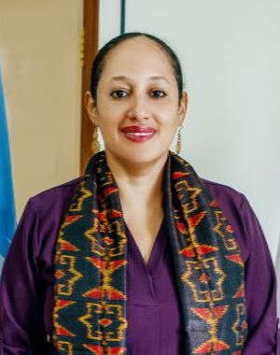
Sierra Leoneans, Unu adu o
Me na Nadia Rasheed, the UNFPA Country Representative n the UN Resident Coordinator ad interim.
Tiday, ar bring una greetings from the 21 UN agencies, funds and programmes way de work na Salone.
I am pleased to convey my warmest congratulations, on behalf of the United Nations (UN) Country Team, to the Government and people of Sierra Leone on the country’s 62nd Independence Day Anniversary.
As we celebrate this special anniversary, we commend the progress made by Sierra Leone in consolidating peace and democracy. Sierra Leone is one of a few countries that once hosted UN Peacekeeping operations, but the country now proudly deploys its peacekeepers to other countries that need international support.
The UN continues to enjoy a strong partnership with the people of Sierra Leone based on shared values and common interests. As a Country Team, we work as ‘One UN’ with the Government and development partners to deliver sustainable development interventions for people, prosperity, planet, partnership, and peace.
Sierra Leone will hold presidential, parliamentary, and local council elections in June of this year. The UN has accompanied Sierra Leone during all post-war elections. All elections were characterized as credible by international observers, and the upcoming elections will be the second since the end of the civil war to be held without the presence of a UN peace-keeping or political mission.
Sierra Leone has good reason to be proud of this evolution. At the same time, national institutions, political actors and all Sierra Leoneans have a great responsibility to ensure that the country remains peaceful and stable, and continues to grow and prosper for the benefit of all.
On this occasion of the country’s Independence Day, I would like to reiterate the commitment of the UN to supporting the people of Sierra Leone and national institutions in sustaining the important gains which this country has made so commendably to ensure peace and democracy.
On behalf of the UN Country Team. Let me wish all Sierra Leonean’s a very happy INDEPENDENCE DAY.
Nadia Rasheed
Resident Coordinator ad interim

Follow us on
Twitter @UNSierra Leone
Facebook- UN in Sierra Leone
Website https://sierraleone.un.org/en

