

**Press Statement**

**United Nations in Sierra Leone announces the formation of its Youth Advisory Group**

**Freetown, 26 May 2023:** The United Nations in Sierra Leone is pleased to announce that after reviewing over 1000 applications from young people across Sierra Leone, 12 persons have been selected for the first UN Youth Advisory Group (UN YAG) in Sierra Leone.

The UN YAG is a group of individuals and representatives of UN Sierra Leone’s stakeholders who have been nominated (either through self-nomination or through a UN Agency) and selected through a diverse team using select criteria. These criteria aimed at a diverse panel taking into consideration gender and geography.

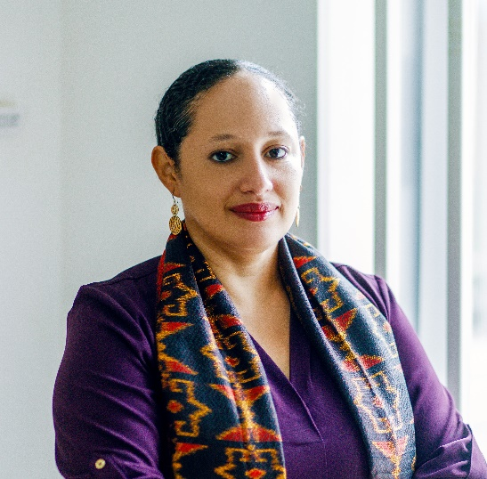The UN YAG will advise the UN Country Team (UNCT) in Sierra Leone on key youth issues of importance.

Members of the UN YAG play a crucial role by providing new perspectives, information, ideas, critiques, and lessons learned to the United Nations Country Team (UNCT). The UN YAG is the primary mechanism for accountability of Youth to the UNCT and of UNCT to Youth, as envisaged by the Youth2030 Scorecard.

UNFPA Representative, Nadia Rasheed who Chairs the Youth Thematic Team (YTT) indicated that, “robust engagement of young people is critical to the success of the 2030 Agenda for Sustainable Development, and as the UN, we are committed to partnering with young people in developing and implementing our programmes and ensuring that their needs are addressed.

Furthermore, Ms Rasheed indicated that the Group represents all regions of Sierra Leone and will it bring diverse perspectives to inform the work of the UN and position youth voices at the forefront of development efforts.

The objective of working with and for youth, is to ensure that UN programmes can better address youth issues and concerns. UN YAG Members will also have an opportunity to learn more about UN programmes in Sierra Leone and the functioning of the United Nations globally.

Membership is for one year, and the UNCT is grateful to the candidates who have all confirmed their willingness to perform the tasks to be assigned.

The next steps shall include an Onboarding process and the Launch of the UN YAG, of which the Youth of Sierra Leone would be duly informed of the process.

#END#