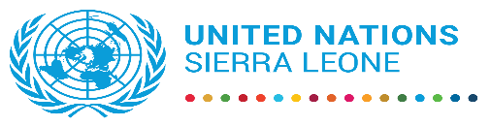

**Press Release**

**United Nations in Sierra Leone  launches  six years  Development Plan aligned with the  Medium Term National Development Plan ( 2024-2030)**

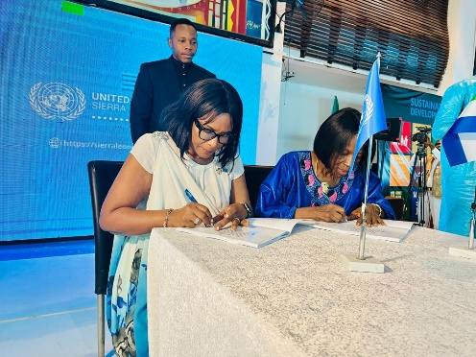**Freetown, Monday, July 29:** The United Nations in Sierra Leone launched its six-year Plan to support the development aspirations of the Government and people of Sierra Leone on Friday, July 26, at a symbolic signing ceremony at the Freetown International Conference Centre, Bintumani.

The Plan, referred to as the United Nations Sustainable Development Cooperation Framework (UNSDCF) 2025-2030, is a comprehensive framework that sets the strategic priorities for the partnership between the United Nations and the Government of Sierra Leone. It was launched by the Chief Minister, Dr David Moinina Sengeh, deputising the President of the Republic of Sierra Leone, Mr Julius Maada Bio.

In her statement, United Nations Resident Coordinator Ms Seraphine Wakana emphasised that the colourful occasion, which was followed by an exhibition event highlighting the impact of the work of the 20 Agencies, Funds, and Programmes operating in the country, marked a significant landmark in the collective drive towards sustainable development, inclusive growth, and improved well-being for all citizens of Sierra Leone.

She said these "have contributed to and will be guided by the priorities and principles outlined in this Framework over the coming six years," noting that Its development was a collective effort of the UN team, working in partnership with key Government and civil society partners, a testament to the inclusive nature of the process. “This collective effort ensures that everyone's voice is heard and considered in the development of the plan,” the Resident Coordinator said.

She thanked the Government, particularly its primary coordination partner, the Minister of Planning and Economic Development (MoPED), Development Partners, Civil Society organisations, the private sector, women and youth organisations, and all those who contributed to shaping the cooperation framework, expressing deep appreciation for their invaluable contributions.

The Resident Coordinator also said that the Cooperation Framework's vision on food security, access to services, development of human capital, inclusive governance, and environmental sustainability mirrored the big five game changers of the Government's Medium-Term National Development Plan (2024-2030), providing a strong reassurance of its relevance and are aligned with the UN Secretary General's six transitions, which aim to accelerate the implementation of the 17 Sustainable Development Goals. This alignment ensures that the plan is in sync with the country's long-term development goals.

In her goodwill message, MoPED Minister Ms Kenyeh Barlay noted that she was pleased that the process of developing the Cooperation Framework was very inclusive. It paid due attention to national systems, procedures and national development agenda. "Very significantly, it ensured that all stakeholders across all regions of Sierra Leone had their say in the priorities of the UN support to Sierra Leone over the next six years," she said, highlighting the transparent and inclusive nature of the process.

Officially launching the Plan, Dr Moinina Sengeh said that the Cooperation Framework is not merely a document, but a testament to our collective aspirations and a roadmap to a future where every Sierra Leonean can thrive, emphasising that the inclusiveness in the drafting process ensured that the document truly reflected the needs and aspirations of Sierra Leoneans.

"What sets this document apart is its emphasis on local ownership, partnership and leaving no one behind. We recognise that sustainable development cannot be achieved through external support alone. It requires the active participation and leadership of Sierra Leoneans at all levels," he said.

The Chief Minister also said that the government cherishes global partnerships and is ready to work with the United Nations System to deliver a cooperation framework for the betterment of our country.

He also spoke about radical inclusion, transparency, data, results and accountability, stressing the need to support reliable data. In conclusion, he extended his heartfelt gratitude to all those who contributed to the development of the Cooperation Framework.

The symbolic signing at the ceremony attended by cabinet Ministers, Deputy Ministers, other government officials, development partners, Civil society organisations, local authorities, the private sector, and the media was done first between the Resident Coordinator and the MoPED Minister, and later by the Heads of Agencies of FAO, IOM, UNDP, WFP, UNOPS, UNIDO, UNAIDS IFAD and UNICEF.

Other highlights at the impressive ceremony were a drama skit by the University of Sierra Leone Theatre Group, which creatively depicted the key elements of the new Cooperation Framework, and a vibrant cultural performance that celebrated the diversity and unity of Sierra Leone. These performances added a unique and engaging dimension to the event.

The Plan will focus on three pillars:

* Food systems, natural resource management, and climate change.
* Human capital, essential services and employment
* Governance and economic transformation

It is now available for download on the UN Sierra Leone website: <https://sierraleone.un.org/en/274732-united-nations-sustainable-development-cooperation-framework-2025-2030>