**AGENCIES WEEKLY HIGHLIGHTS – 20-24 JANUARY**

**Sierra Leone hosts Youth Empowerment Programme 2025**

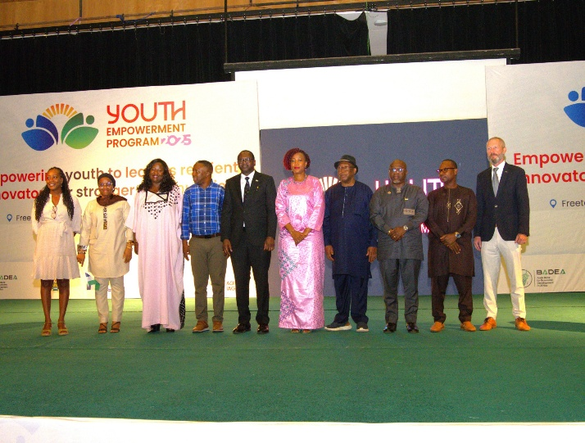Sierra Leone hosted a 3-day Youth Empowerment Program 2025 this week, bringing together 500 young individuals in Freetown. Organized by the Africa Institute of Governance, with support from key partners, including the BADEA Arab Bank for Economic Development in Africa, the Ministry of Youth Affairs, the Office of the First Lady, and the United Nations Development Programme (UNDP), this event aimed to empower the next generation of Sierra Leoneans by equipping them with the skills, knowledge, and resources needed to thrive in today’s world. Speaking at the opening ceremony, the First Lady of Sierra Leone, Fatima Maada Bio, encouraged the young to stay focused on their goals and remain committed to the growth and development of Sierra Leone.  The Resident Representative of UNDP, Mr Fredrick Ampiah UNDP, stressed the urgent need for investments in young people, highlighting the importance of empowering them for meaningful livelihoods. He said, “Investing in young people is key to unlocking their potential and empowering them for meaningful livelihoods.” The #YouthEmpowermentProgram 2025 opportunities offer mentorship, networking, funding, capital access, and entrepreneurial development support. It also provides opportunities for participants to learn from industry experts and network with fellow youth leaders. It is also about creating lasting change by providing the resources and guidance for youth to thrive in an increasingly competitive world.

**UNICEF supports Mpox response**

Coordination: Supporting health authorities in planning and implementing response strategies.

Infection control/WASH: Ensuring infection prevention by supplying water and hygiene materials for health facilities providing treatment

Case management: Supporting health authorities community surveillance and supplying personal protective equipment (PPE).

Vaccination: UNICEF is collaborating with WHO and health authorities in exploring options with Gavi and Africa CDC for potential vaccine delivery in the event of an outbreak and ensuring cold chain management, while also maintaining essential routine childhood vaccinations.

Risk Communication: Engaging on risk communication efforts to raise awareness and prevent further spread of the virus by developing information materials for school children and the general public including travellers.

U-Report Sierra Leone: And earlier in 2024, rolled out two U-Report Polls on MPox to check the knowledge levels across the country regarding preparedness, actively engaging with over 6,000 young people.

**UNOPS conducts joint monitoring visit:**

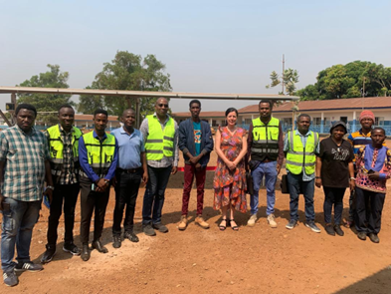During the week in review, The United Nations Office for Project Services, together with the Ministry of Energy and the Presidential Initiative on Climate Change, Renewable Energy, and Food Security, conducted a joint monitoring visit to seven educational and health facility sites in three districts of Sierra Leone where solar stand-alone systems are installed. The visit was aimed at assessing the ongoing work of UNOPS on the installation works of the 404 education and health facilities stand-alone solar systems aimed at electrifying schools and hospitals across the country. These renewable energy systems will provide community health centres with clean, reliable electricity, helping to improve the quality of healthcare delivery to patients and improve educational outcomes on retention in schools. UNOPS in Sierra Leone is implementing the Enhancing Sierra Leone Energy Access Project (ESLEAP)) with funding from the World Bank on behalf of the Ministry of Energy. This project aims to increase energy access in Sierra Leone through electrification through mini-grids and standalone systems

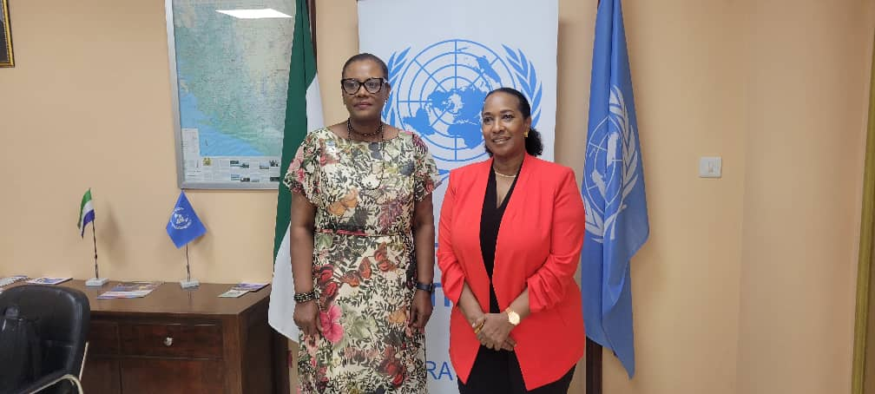**RCO: UN Resident Coordinator discusses development priorities with ITC’s Executive Director**

On Wednesday last week, United Nations Resident Coordinator Seraphine Wakanareceived at her office in Freetown the International Trade Centre (ITC) Executive Director Pamela Coke-Hamilton and her team who were in the country for the launch of a four-year project on Empowering Youth Through Digital Technologies Project (READY Salone). The project will strengthen Micro, Small, and Medium Enterprises and increase awareness of digital technologies and skills of young people in various communities and the ITC implemented programme is funded by the Korean International Cooperation Agency. The Executive Director also met with the United Nations Country Team. She briefed them on her mission and also discussed how ITC coordinate their efforts with the Country Team in meeting the development priorities of the country.

**ITC: 4-yr Ready Salone Project launched in Freetown**

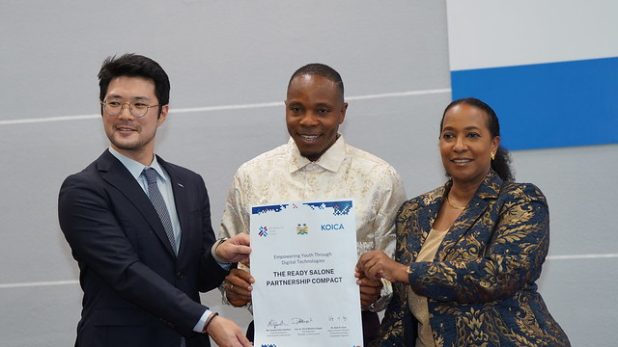 The visiting ITC Executive Director, Pamela Coke-Hamilton Thursday joined the Chief Minister of Sierra Leone, Dr David Moinina Sengeh and Baik Kihyun, the Deputy Country Director of the Korean International Cooperation Agency (KOICA) responsible for Sierra Leone, for the signing and launch of the four-year (July 2024- July 2028) Empowering Youth through Digital Technologies’ (READY Salone)’ project. The ceremony held at the Foreign Service Academy in Freetown was also attended by the Ministers of Trade and Industry, Youth Affairs and Communication and Innovation, as well as young entrepreneurs and innovators. Funded by KOICA and to be implemented by ITC, the project aims to contribute to economic growth and job creation in Sierra Leone by enhancing youth participation in the digital economy. It also aims to increase youth’s participation in the digital economy and the economic opportunities for 3,000 young people and enable 250 MSMEs to access new markets through four intervention areas, including - Increasing the capacity of youth to use digital technologies.

The Executive Director also paid a courtesy visit on His Excellency the President, Dr. Julius Maada Bio, who warmly welcomed her and the ITC Delegation to Sierra Leone. She briefed the President on ITC’s interventions in Sierra Leone over the last 38 years and upcoming programmes. The Executive Director commended the president’s remarkable developmental strides and the “5 Big Game Changers” Initiative to transform Sierra Leone, especially in agriculture. She announced ITC’s commitment to supporting the 5 Big Game Changers” and establishing a permanent office in Freetown. - President Bio commended the decision to establish an ITC office in Sierra Leone and emphasized the importance of food security and human capital development to national development, citing the Feed Salone initiative as a key driver of increased agricultural productivity.

**WFP launches Nyam Nyam Pap for children 6-23 months**

WFP in partnership with the Ministry of Health, the Directorate of Food and Nutrition and Choithram Memorial Hospital last Friday launched the locally produced complementary food enriched with minerals and vitamins for children 6-23 months. The food known as Nyam nyam pap is produced by women groups supported by WFP in Pujehun and Kambia districts. The goal is to increase access to and affordability of complementary foods to caregivers.

**UN Women Sierra Leone Hosts Training for Irish-Aid Partners:** UN Women Sierra Leone hosted a transformative two-day training workshop for Irish Aid-funded project partners, focusing on enhancing accountability and delivering impactful results. Held at the UN Women's Office, the workshop gathered 30 participants from national and community-based NGOs and CSOs. The aim was to bolster skills in financial management, project monitoring, and effective communication of results and lessons learned. The program featured practical sessions on communication for change, including storytelling for influence, basic photography and videography, and ethical communication standards. Participants gained new tools to better convey their projects' successes and challenges, with guidance on incorporating human rights considerations to ensure their messaging upheld values of equality, dignity, and respect. The training's hands-on approach was impactful, allowing participants to practice storytelling, engage in video and photo projects, and explore effective documentation of change.

The workshop concluded with a presentation from an Irish Embassy representative, offering practical examples of effective communication for Irish Aid-supported projects. UN Women's Head of Office, Setcheme Mongbo, emphasized the shared responsibility of accountability, reinforcing the importance of starting right to achieve desired results. Participants left empowered with knowledge, tools, and confidence to drive greater community impact.

**Advancing Women's Economic Empowerment in Sierra Leone: A UN Women ChangeMaker's Perspective**

Catherine Smith: A UN Women ChangeMaker based in Bo district last week shared her inspiring journey focused on advancing women's economic empowerment through agriculture, highlighting significant progress and personal growth. Reflecting on her experience as a UN Women ChangeMaker so far, she described it as "refreshing," noting that her exposure to new agricultural practices has been both educational and transformative. "These days, I'm learning more and more about agriculture," she said. "I've witnessed firsthand how Garri is processed from scratch and how animal feeds are made. I feel like a farmer already." One of her key highlights this week was discovering that animal foods, which were previously imported, can now be produced locally in Sierra Leone. She credited this transformation to resources and equipment donated by UN Women, which have revolutionized agricultural practices in the region.

In addition to her work in agriculture, she highlighted how her background in Economics has been a valuable asset in contributing to her role's administrative and technical aspects. "Providing technical support and being part of the administrative work here in Bo has been a great experience for me," she shared. "I am learning and unlearning every single day."

**WHO Strengthens Mpox Response in Sierra Leone**

The World Health Organization (WHO) continues to collaborate with partners to support the government led response to the Mpox outbreak. Key contributions include:

-Procurement of commodities and supplies for testing and confirmation of cases, infection prevention and control (IPC), and case management.

-Submission of the national vaccination plan to the global secretariat to protect 25,000 high risk individuals, including health care workers.

-Operational and technical support to the national level and affected districts to identify and manage cases and monitor their contacts.

- Collaboration with RCCE pillar and partners to develop IEC materials for engagement of schools and communities.