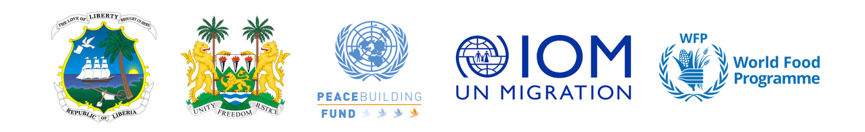

**Media Advisory**

**US$4 million GOLA-REAP Project to Launch at Bo Waterside, Liberia**

**Strengthening Sierra Leone-Liberia Collaboration**

*26 February 2025*

**[Freetown/Monrovia]:**Tomorrow (Thursday 27 February) the Minister of Internal Affairs from Liberia, Francis Sakila Nyumalin, his Sierra Leonean counterpart, Morie Lengor, and the UN Resident Coordinators for Liberia and Sierra Leone, Seraphine Wakana and Christine N. Umutoni respectively, will lead a significant event at Bo-Waterside, Liberia for the launch of the GOLA- REAP (Resilience, Empowerment, Access and Peacebuilding) project.

The initiative, US$4 million in catalytic funding from the UN Peacebuilding Fund (PBF), aims to enhance cross-border collaboration, resilience, sustainable livelihoods, and peacebuilding among communities, law enforcement, and government agencies in Liberia and Sierra Leone. PBF supports joint UN responses to address critical peacebuilding opportunities, connecting development, humanitarian, human rights and peacebuilding initiatives.

The GOLA-REAP project will be a collaborative effort bringing together diverse stakeholders including Government Representatives from the Ministries of Agriculture, Youth & Sports, Environment, Forestry Development Authority (FDA), Liberia Immigration Service (LIS), and their counterparts in Sierra Leone. Chiefdom members from both project sites, the local authorities, and other stakeholders and beneficiaries will also be at the launch.

The launch event will serve as a key milestone in officially presenting the project to stakeholders, highlighting its objectives and intended outcomes. These outcomes, which include strengthening peace, security, and resilience along the borders of the two countries, strengthening social cohesion, improving border management, enhancing local governance, and promoting climate-smart agriculture to mitigate conflict risks and foster economic resilience, offer a beacon of hope for the future.

The GOLA-REAP project is a joint effort led by the International Organization for Migration (IOM) and the World Food Programme (WFP) in Liberia and Sierra Leone. The IOM will provide its expertise in migration and border management while the WFP will contribute its experience in food security and nutrition, in collaboration with national governments, local authorities, civil society organizations, and regional institutions such as the Mano River Union (MRU).

***For further information, please contact:***

In Monrovia, Serge Lenaud: [slenaud@iom.int](mailto:slenaud@iom.int)

In Freetown, Sam Whitlow: [rwhitlow@iom.int](mailto:rwhitlow@iom.int)